File Manager at New-country.com

- Functions
- Changing view between list and grids - $10
Grid View – Desktop, Laptop, Smart TV – Only List view change from desktop only | List View - Mobile
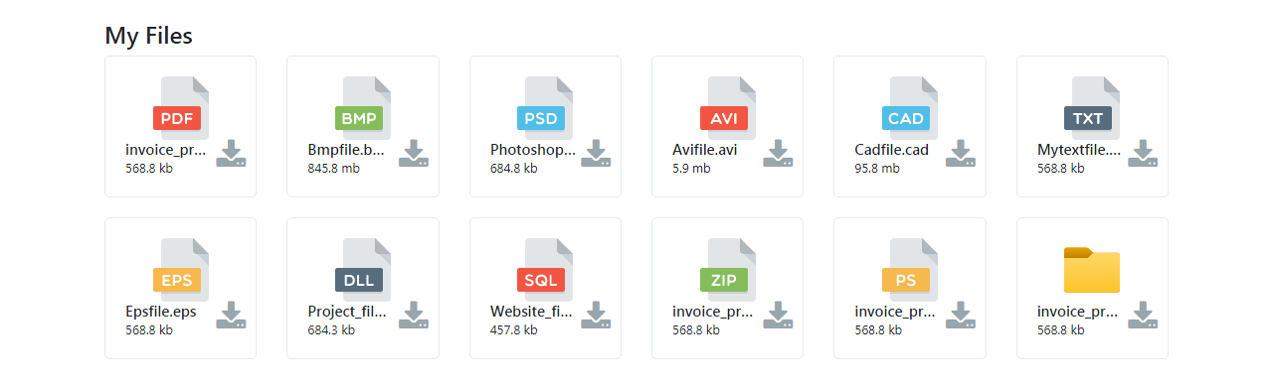  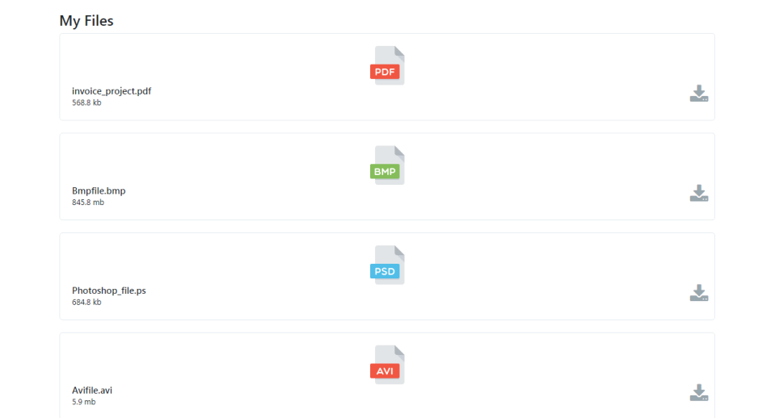 | 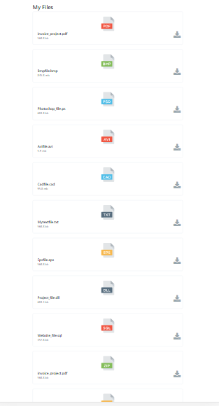

- Fully responsive design - $10 – Bootstrap & Design given above image
- Functions that photos have now: show, edit, delete - $5
- Album list modification - $30
- Photo list modification - $30
- Additional Features:
- Trash – $20
- Move, Copy – $10
- 5 GB Storage Algorithm – $25
- All types of files upload – $15
- Show Album List – $5
- Submenu – Trash Functions – Remove & Restore – $13
- WeTube Functions To Allow Shoeing All type of files - $20
- .txt
- .pdf
- .auc
- .mov
- .xls – User can download only
- .pptx - User can download only
- Share to ChatBox - $10

- IN GRID VIEW FOLDER WILL LOOK LIKE:
Folders Will Look Like This
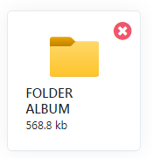

Discounts | Total
$13 | $203-$13
 | Grand Total: $190/=

